

**Figure S1**. Body mass at the time of vaccination (10th October 2016) within eight groups of Atlantic salmon kept under different environmental conditions. Data are means ± 95% CI (*n* = 141-176 group-1). The results from linear mixed effect models. Different lower-case letters indicate significant O2 saturation effect within 12 °C whereas upper case letters indicate significant O2 saturation effect within 17 °C (post hoc, lsmeans, *p* = <0.05).



**Figure S2**. Gill mRNA expression of the ratio between Na+, K+ -ATPase α-subunit isoforms α1a (FW) and α1b (SW). Groups on the x axis categorised as vaccination status (UV = unvaccinated, V = vaccinated) – temperature (12 or 17°C) – O2 saturation (60, 70, 80, 100 %). Those fish reared at 17°C were shifted to seawater after the sampling on week 4. Data are means ± SEM (*n* = 8-12 group-1). The analysis was conducted by Pharmaq Analytic AS (Bergen, Norway), therefore the primer sequences are protected.



**Figure S3**. The effect of post-smolt maturation and cataracts on growth. For both, only data from the 17°C treatment groups were analysed. For maturity we used the model; mature (Y/N) × time (October 2016, November 2016, April 2017, categorical) with fish within group (60% O2 unvaccinated/70% O2 unvaccinated/80% O2 unvaccinated/100% O2 unvaccinated/60% O2 vaccinated/70% O2 vaccinated/80% O2 vaccinated/100% O2 vaccinated) included as a random effect. Only data on males was analysed as no females matured. For cataracts, we used the model; cataract (Y/N) × time (October 2016, November 2016, April 2017, categorical) with fish within O2 saturation (60/70/80/100%) used as a random effect. Only data from unvaccinated immature fish was used. Data includes means ± 95 % CI. In (**A**) *n* = 48-274 and in (**B**) *n* = 33-283, group-1 time-1. An asterisk indicates a significant group effect within a given time point (post hoc, lsmeans, * *p* = <0.05, *** *p* = <0.001).

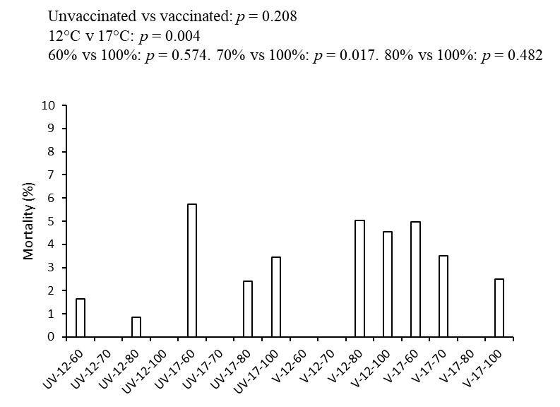

**Figure S4.** Total mortality in Atlantic salmon vaccinated under different environmental conditions. The statistics from binomial tests are presented. Data are means (*n* = 96-122 group-1). UV = unvaccinated, V = vaccinated, 12 and 17 refer to °C, and 60, 70, 80, and 100 refer to % O2 saturation.